Project A: The Tie Fighter and the Checkpoint

Anne Barrett

abp818

This report outlines the goals, usage and outcomes of my project and includes images and scene graphs of the created objects.

*Section 1: User’s Guide*

The goal of this project was to create various three dimensional shapes that were clearly different and unique from each other. As for what those shapes would be, the idea began to form that creating a simpler version of the Tie Fighter from the Star Wars universe as well as an object that resembled a game checkpoint could be the building blocks for a game using WebGL. The motivation for adding an arm object was to present a possible antagonist to this game idea. The next section will explain how to manipulate these objects and use the program.

Upon opening the html file in the browser, there will be a set of basic instructions on how to move and alter the objects on screen. There are three different objects on the screen that the user can interact with: a Checkpoint, a Tie Fighter, and an Arm. See Figure 1 for images and locations of each object. There are several different types of controls the user can choose: mouse-drag, mouse-click, button submissions, and keyboard inputs. For simplicity, we will look at the interactions based on what object they effect.

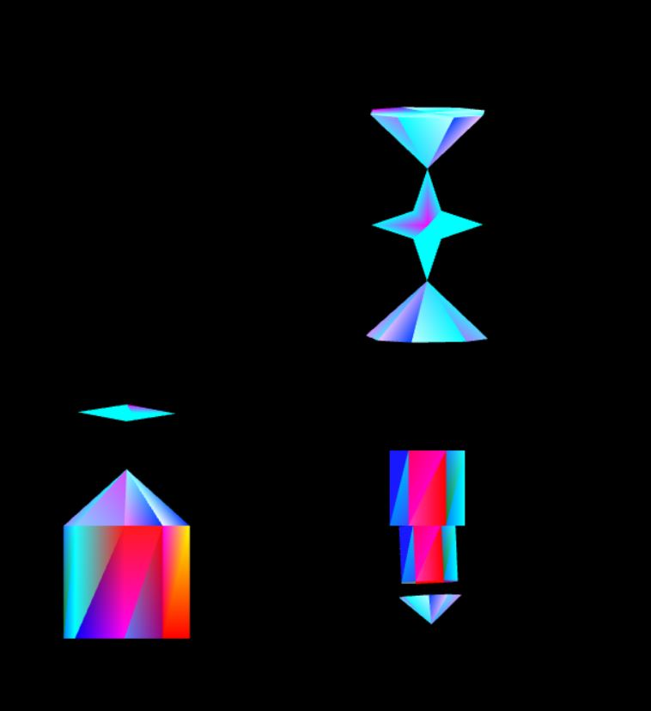 *The Checkpoint:* By entering a number into the input box on the page, the user can alter the scale of the octagonal base. To avoid going off the bounds of the canvas, the highest number that will be implemented is 4.0. Anything larger than that and the program will automatically scale to 4.0. The same goes in the opposite direction. The smallest number that will be considered is 0.5. When a number is entered, the checkpoint will gradually grow or shrink. The other interaction available for this object is stopping and starting the rotational movement. This can be done by pressing on the button labelled “Freeze/Start Checkpoint.”

The Tie Fighter

The Checkpoint

Figure 1

*The Tie Fighter:* The Tie Fighter can be moved around the canvas by clicking and dragging the mouse across the screen. The rotation of the “wings” of the Tie Fighter can also be sped up or decreased by clicking the corresponding buttons. Once the rotation of the wings reaches zero, however, the rotation will remain at zero until the user clicks the Increase Tie Fighter Spin button.

The Arm

*The Arm:* The last object has two interactions available to it, and the first is from the user clicking the canvas. When the user clicks the canvas, the rotation of the second joint is stopped. This does not stop the rotation of the “hand” pyramid. The other interaction is from keyboard inputs. When the user presses the “w” key, the object moves up. Pressing the “a” key moves it left; “s” moves it down; and “d” moves it right.

*Section 2: Results*

The below pictures illustrate the program. The top is a screenshot of the Instructions available when opening the html file. The bottom three exhibit different states of the program. The first is the initial state. The second is after the checkpoint has been stretched to 4.0, the Tie Fighter dragged around the screen and the arm moved with arrow keys. The last also shows new locations for the arm and Tie Fighter but the Checkpoint has been stretched to 0.5.

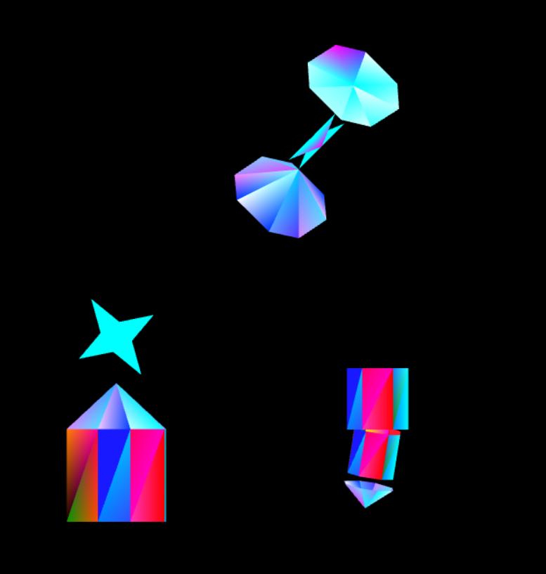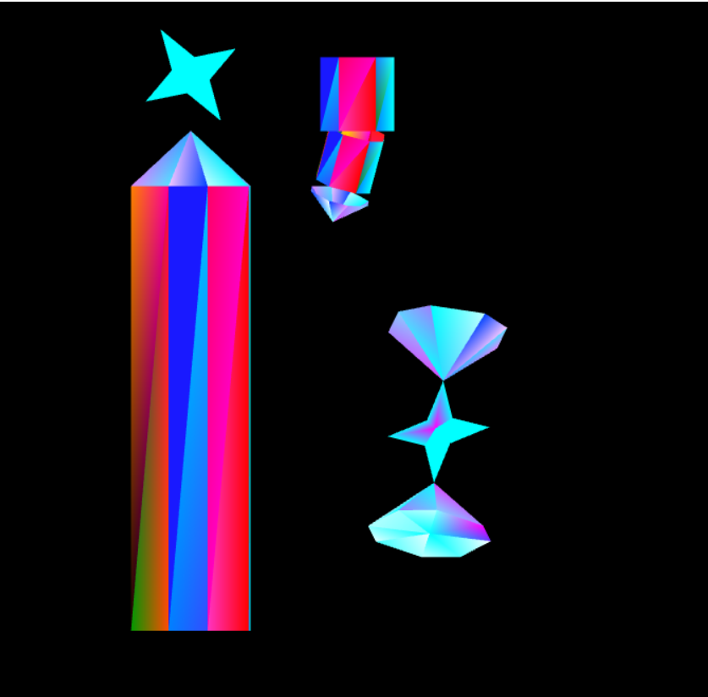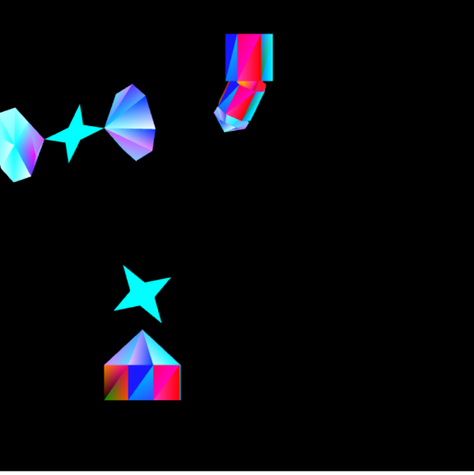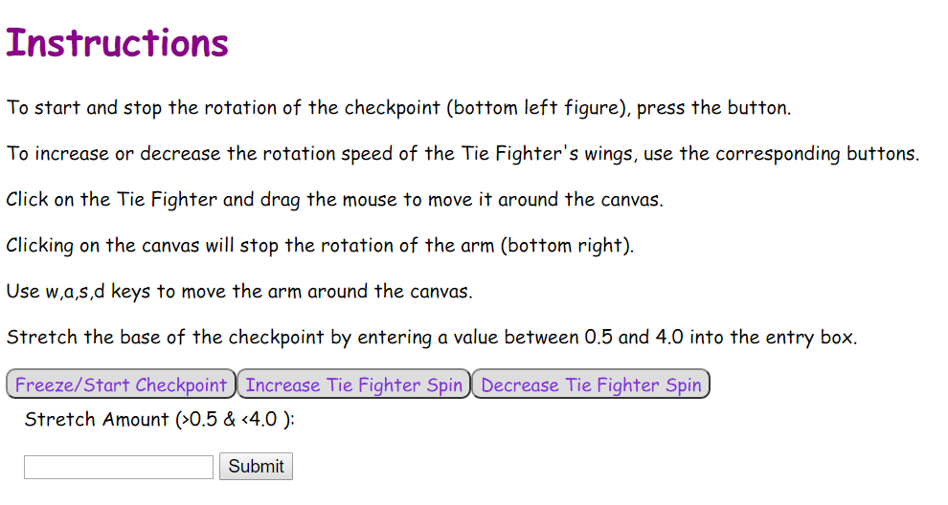

Below is a scene graph diagram of the project. The nodes labeled with T mean a matrix translation. Those labeled with R mean a matrix rotation. Some have T, R which means a translation then rotation.

